
Visual designs
Denas Malysevskis


Table of Contents
Visual Designs 3
Algorithm Design 4
Login Flowchart 4
5
Data Requirements Design 6
Test Strategy 6

Visual Designs

Algorithm Design

Register Flowchart
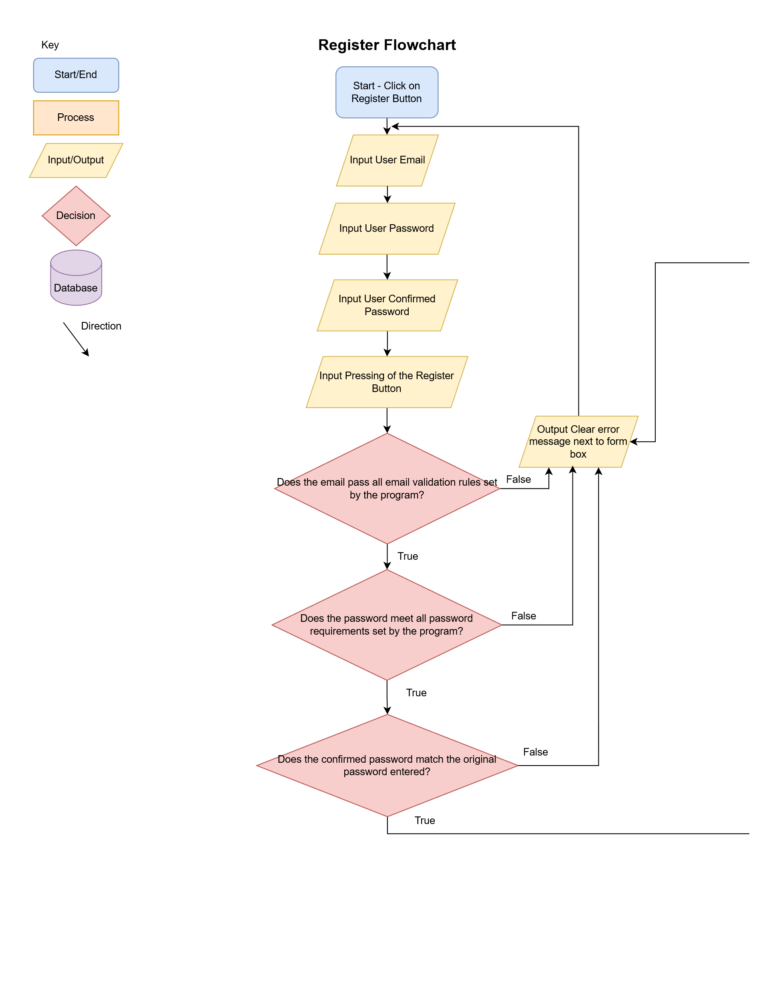

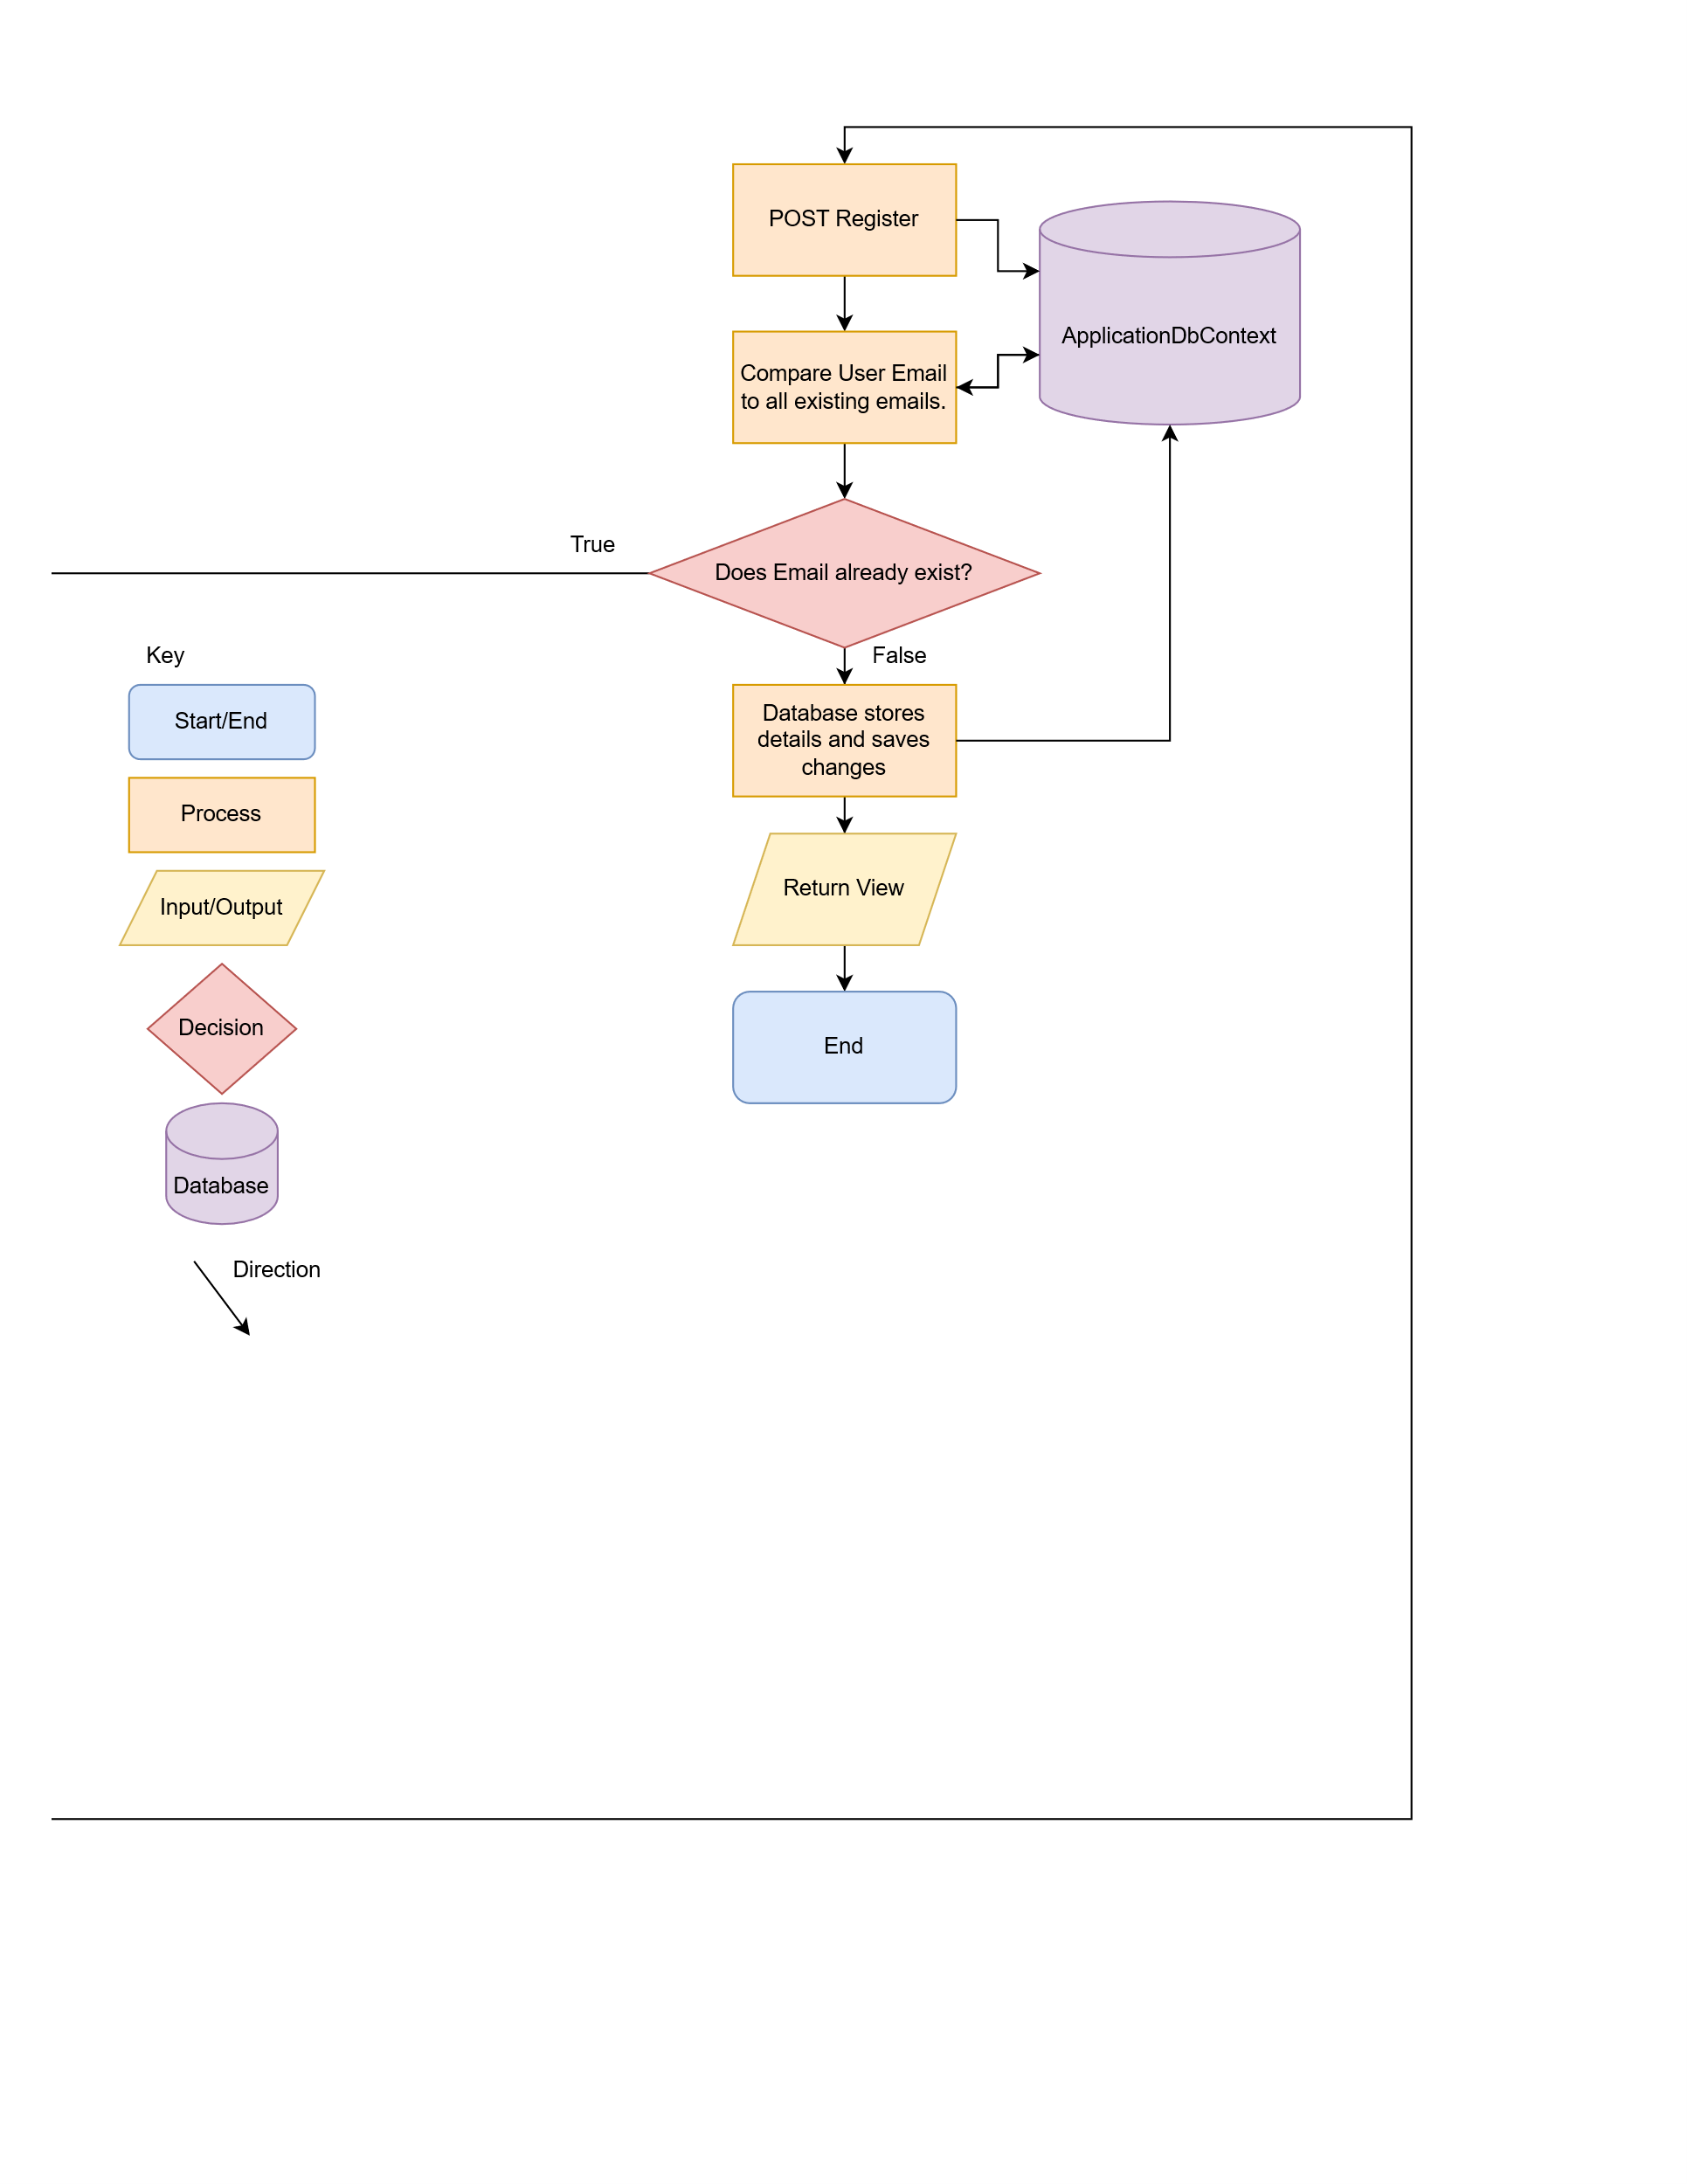

Data Requirements Design

Test Strategy

Column | Data Type | Required? | Default | Validation | Key Types

